Hazards identified | Personal protection required & safety devices
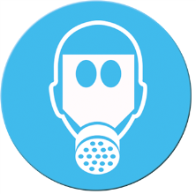
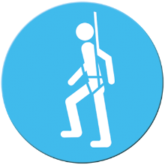
Material required | Equipment required
Training required | Permits/Approvals required
PROCEDURE
Guidance documents |  | Standards/Applicable legislation
- Include employer documents, owner’s manuals, SDS, etc. |  | - Saskatchewan Employment Act, Occupational Health and Safety Regulations, CSA, ANSI, etc.

The information/training provided is not a substitute for nor does it take precedence over The Workers’ Compensation Act. This form does not take the place of or take precedence over OH&S legislation. This form may be used to complement or supplement your OH&S obligations but in no way replaces any obligations that exist under OH&S legislation. Should you choose to use this form, WorkSafe Saskatchewan assumes no responsibility or liability for any outcomes that may arise from its use. All employers and workers should be familiar with The Workers’ Compensation Act, The Saskatchewan Employment Act and The Occupational Health and Safety Regulations. This form should be adapted to meet the particular requirements of your workplace.
v1r2_171024

